Tyler Vander Mooren designed and implemented the main Cassandra data model, including the query-focused tables for sensor readings, latest readings, threshold violations, device registry records, and daily aggregates. Thomas Peaslee assisted with final database access setup, project completion documentation, and instructor review access.
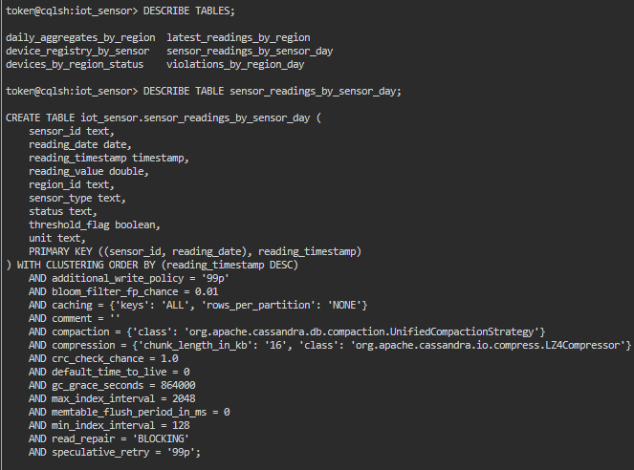
Tyler Vander Mooren created and loaded the main sample data for sensors, readings, violations, latest readings, and aggregate reports. Thomas Peaslee reviewed the database setup and contributed to final submission preparation and access configuration.
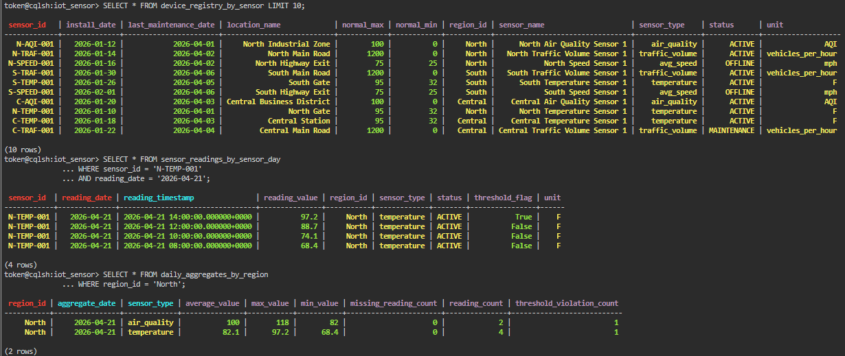
Tyler Vander Mooren implemented the core query patterns and tested the project queries in Astra DB. The queries demonstrate time-series retrieval, threshold violation lookup, latest regional readings, daily aggregation reports, and communication failure/status lookup. Thomas Peaslee assisted with final review and access setup.

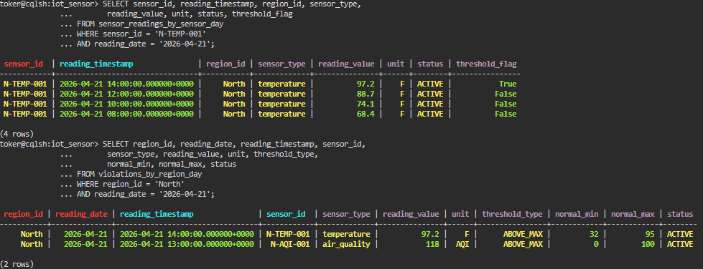
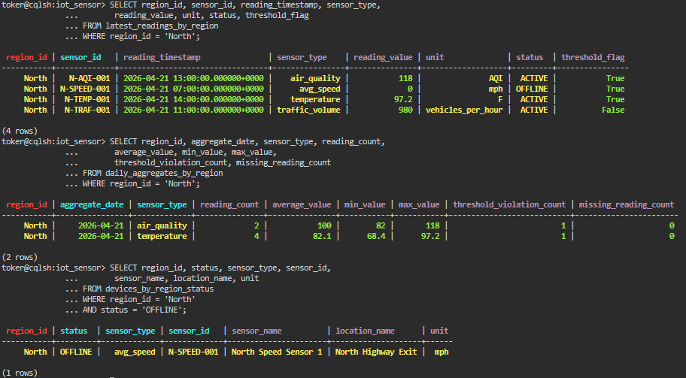
Short Scope:
The project scope was reduced for a two-person team. The final implementation focuses on three core entities: Sensor Readings, Device Registry, and Daily Aggregates. Advanced features such as anomaly detection, predictive maintenance, correlation between related sensors, compliance reporting, and full alert notification workflows were intentionally removed from scope. Threshold values and device maintenance fields were kept inside the device registry where appropriate to preserve basic functionality without expanding the project beyond the approved reduced scope.
Data Quality
The project implements multiple data quality features. First, readings include a threshold_flag field and threshold violations are stored in a separate query table for efficient review. Second, device status values such as ACTIVE, OFFLINE, and MAINTENANCE support communication failure tracking. Third, daily aggregates include missing_reading_count, which supports basic missing data review.
Time Series:
Time-series data is bucketed by reading_date and sensor_id to keep partitions bounded and support efficient range queries. In a production IoT system, raw readings could be retained for a shorter period using TTL or archived after a retention window, while daily aggregate records could be retained longer for reporting and analytics.

